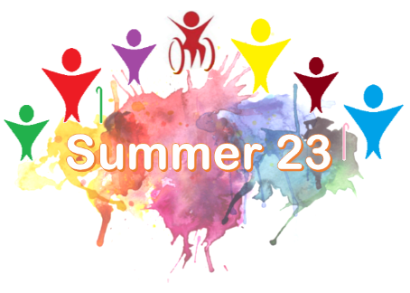
Parent/Carer registration form

This form is to be completed for all young people who attend the Summer 23 activities at Christ Church and St Peter’s without a parent/carer in attendance.

The information provided is held in accordance with the General Data Protection Regulations (GDPR) and used for the purposes of the Summer 23 Activity Week only.

Please complete details for the child/young person:

Personal Details

First Name |  | Surname
Date of Birth |  | Age
Address

Medical Details
Please list any health/mental health condition or disability that we need to be aware of and/or which may affect your child fully participating in activities.
Please list any allergies/intolerances that your child has.

Emergency Contact Details
Name of Parent/Carer |  | Relationship
Address
Mobile Number |  | Alternative Number

Name of Parent/Carer |  | Relationship
Address
Mobile Number |  | Alternative Number

Pick up arrangements
My child can go home on their own | Yes / No (Please delete as appropriate)
My child will be collected by:

Photo Consent
We sometimes take photos and/or videos during our activities and need to obtain your consent for this; please tick ONE of the options below:

□ I am happy for photographs/videos to be taken of my child during Summer 23 activities and used for publicity, communications and publications including social media.
□ I do not wish any photographs/videos to be taken of my child while they are at Summer 23

We are committed to ensuring that photos and videos are kept securely and that consideration and sensitivity is shown in their appropriate use

Signed by Parent/Carer
I give permission for my child to join in the Summer 23 activities for which they have tickets and confirm that the information provided is correct to the best of my knowledge.

Signed |  | Print name
Date |  | Relationship

We would really like to keep in touch and let you know about other events and Youth activities in the future. If you would like to be placed on our mailing list please write your email address below.

Email

Please either print out this form and return it to Christ Church or email it to Kat.Jenkins@MountsorrelChurch.org

